**Portfolio optimization**

by: Ekapope Viriyakovithya , James Ponce, Deborah KEWON , Saeed Mirzaee, Usman Muhammad

**Introduction**

In this study, we aimed to create a model using AMPL to propose investors to effectively manage their stocks and to invest on the most profitable stocks. We collected stock market data of 500 companies from IEX Group [(https://iextrading.com/developer/ docs - getting-started)]((https://iextrading.com/developer/ docs" \l "getting-started)) and allocated the assets based on the principle of portfolio optimization.

**Data description**

Firstly, we randomly retrieved 500 stocks from the total 8,718 stocks in the U.S. market with the period of 5 years (1258 trading days). Each row is the closing price of a stock for the designated trading date. However, using student version of AMPL software, we are allowed to compute only up to 300 variables for a non-linear problem (500 for linear problem). Therefore, we omitted 200 stocks in the second step. We aggregated stock prices by mean and grouped by month, and then calculated average percentage changes, covariance, and used them as inputs for AMPL.

**Model description**

In this study, we used two models; minimum covariance and Young’s minimax, which are described below.

***Minimum covariance model***

A minimum covariance portfolio indicates a well-diversified portfolio that consists of individually risky assets, which are hedged when traded together, resulting in the lowest possible risk for the rate of expected return and it can be calculated based on the functions below:

*Objective function:*

*Subject to:*

***Young’s minimax model***

The essence of this model lies in the minimax formulation of game theory, so the objective function is to maximize the minimum returns of the portfolio subject to constraints.

*Objective function:*

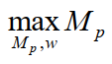

*Subject to:*

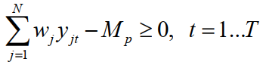

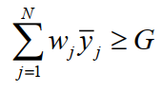

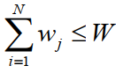



The target of the objective function is the maximization of the portfolio’s minimum returns (*Mp*).

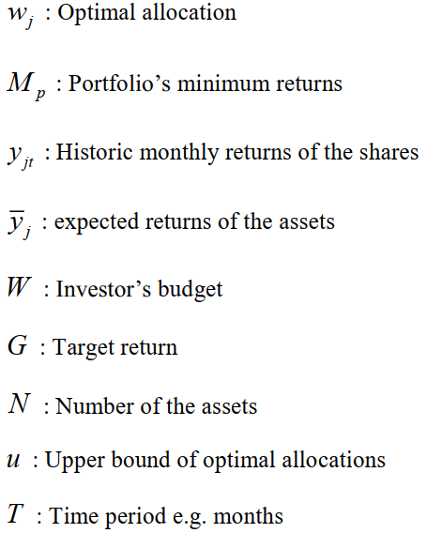

**Implementation of AMPL**

**a. Mean and Covariance**   
For the implementation of the model in AMPL, this standard mean-covariance model, includes three constraints. The first one is in regards to the return of investment, the second one refers to the budget, and the last one is the upper and lower bound constraints. The objective of this model is to minimize the variance. The information required to implement the model is as follows.

Parameters:

* Number of stocks (N).
* Covariance matrix (c).
* Matrix of Mean return (r).
* Upper limit for investing in a single share (u).
* Return of investment (alpha).

Variables:

* Matrix of Weight of the stocks (w).

Constraints:

* Return of investment
* Budget constraint
* Upper and lower bound constraint.

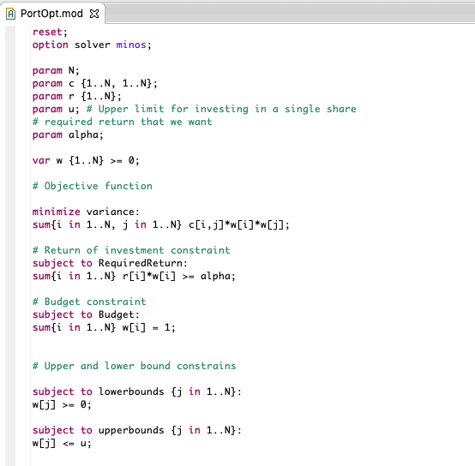

**Results**

We ran the model with return of investment (alpha) equal to 0.03, 0.04 and 0.05, the results obtained are as follow.

For target return (alpha) equal to 0.03

* The minimum variance obtained is 0.0011, this value recommends allocating the investment as follows: **24% in stock number 29**, 9% in stock number 76, 0.9% in stock number 84, 0.7% in stock number 95, 2% in stock number 101, 3% in stock number 135, **12% in stock number 187**, 1.5% in stock number 198, 0.7% in stock number 240, 5.4% in stock number 242, 7.5% in stock number 243,**17% in stock number 267**, 8% in stock number 279, 5% in stock number 283.
* Notice that in this case, the model allocated the investment in **14 stocks**.

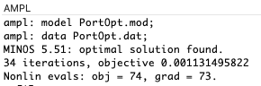

For target return (alpha) equal 0.04

* The minimum variance obtained is 0.006, this value recommends allocating the investment as follows: 9% in stock number 135, **24% in stock number 187**, 5% in stock number 198, 3% in stock number 242, **20% in stock number 243**, **25% in stock number 279** and 10% in stock number 283.
* Notice that in this case, the model allocated the investment in **7 stocks**.

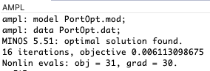

For target return (alpha) equal 0.05

* The minimum variance obtained is 0.054, this value recommends allocating the investment as follows: **33% in stock number 135**, **27% in stock number 243**, **24% in stock number 279** and 14.8% in stock number 283.
* Notice that in this case, the model allocated the investment in **4 stocks**.

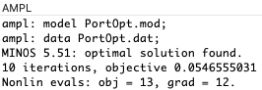

Based on the obtained results, we can clearly see the negative relationship between the risk (variance), and the diversification of the portfolio, which is represented by the number of stocks where the model allocates the investment. In other words, the more the asset is diversified in portfolio, the less risk there is vice versa.

On the other hand, we notice the negative relationship among the target return and the diversity of the portfolio. In other words, the more target return expected, the less diversity in the portfolio.

**b. Minimax**

In addition to Markowitz’s mean-covariance analysis for the best combination of expected return and risk, Young introduced the Minimax model, which is based on the minimax decision rule in the game theory. The objective of this model is to maximize the minimum returns subject to constraints as explained in the introduction.

Our model file contains the definition of the parameters, variables and formulations:

***n*** = number of stocks

***T*** = number of months

***W*** = budget

***RetMat*** = past monthly returns for 300 selected shares

***u*** = Upper limit for investing in a single share

***G*** = target return of the portfolio

***Mp*** = minimum portfolio

***ExpRet*** = expected returns of stocks

***stdv*** = standard deviation of stocks

Our objective function, which maximizes the minimum return is as below:

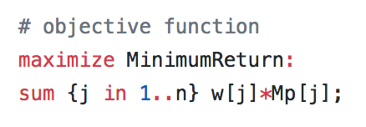

It is the result of subtraction between standard deviation of stock[j] and expected return of stock[j].

In order to calculate the objective function, MP (minimum portfolio) should be first defined. Mp can be calculated using the following functions:

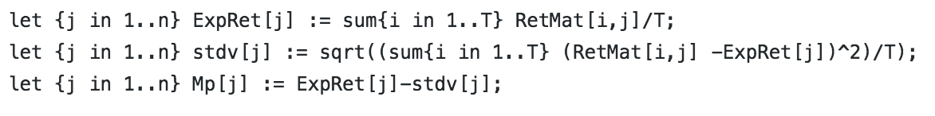

Expected return is the average of the past returns for 60 months.

We applied four constraints 1) the sum of expected return should be equal to or greater than our target return 2) investment(asset) allocation cannot be greater than our budget 3) lower bound of allocation is equal to or greater than 0 4) upper bound of allocation is equal to or less than limit for investing in a single share.

As for the budget, we used the percentage because percentage well reflects the change in a single stock even taking the scale into consideration. Using an actual amount for the budget can be very confusing as we do not know the actual value of each stock. The prices of certain stocks can be a lot higher than the prices of others. Therefore, we defined budget =1 (100%), so in that way we can easily compare the allocation %.

**Results**

1. With the 3% target return, we obtained -0.05 minimum return, which means the lowest % of return we can get is -0.048. Based on our input, we are advised to allocate 50% for stock 187, 46.7% for stock 101, and 3.3% for stock 279 (this allocation % is by month).
2. With the 4% target return, we obtained -0.13 minimum return. We are advised to allocate 50% for stock 243, 8.5% for stock 135 and 41.5% for stock 279.
3. In order to test the limit of target return, we also set the target return equal to 5%. With this input, we obtained -0.27 minimum return. We are advised to invest 50% of our budget for stock 243, 33.2% for stock 135 and 16.8% for stock 279.

**Findings**

1. Stock 135, 243 and 279 are highly recommended for investment
2. The higher the target return is, the riskier it is to invest

ex) when the target return increased from 3% to 5%, the minimum return also increased from - 0.048 to -0.27

**Conclusion**

The proposed financial optimization model assists the investor to make the best decision for asset allocations in finance in order to both ensure his investments and have a satisfactory return of his portfolio. It is well-known that algebraic modelling languages are ideal tools for rapid prototyping and optimization model development. Thus, our proposed portfolio optimization model utilizes the flexibility and convenience of the AMPL modelling language. A strong point of the proposed work is the variety of the state-of-the-art portfolio optimization models which aim is to advice the investor about the optimal asset allocation.

Furthermore, the code of this model can be easily extended or modified, since the majority of the operational and financial researchers are rather more familiar with mathematical modelling languages than with common programming languages.

**Suggestions**

For future implementation, we can include the concept of complementary stocks as a constraint. For this improvement, its necessary to work previously with the dataset in order to include a new feature “the relationship among stocks” (positive or negative).

**Appendix**

Young’s minimax model when G (target return)=0.03

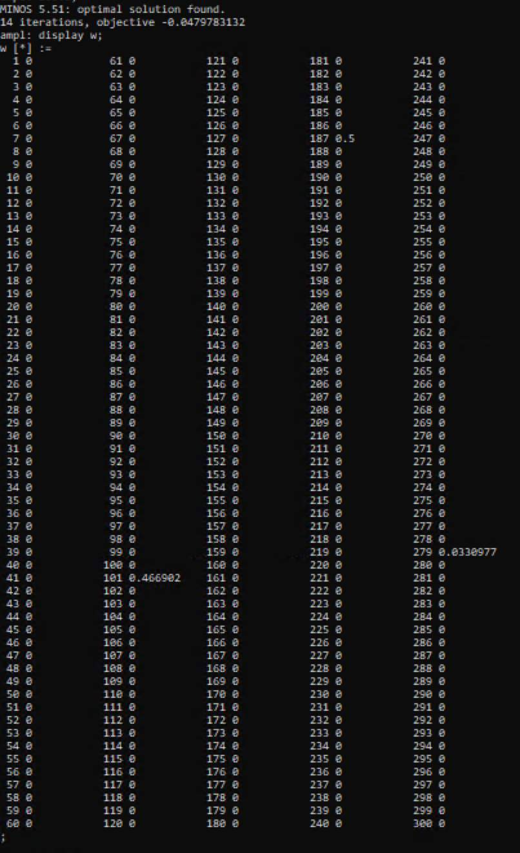

Yong’s minimax model when G (target return)=0.04

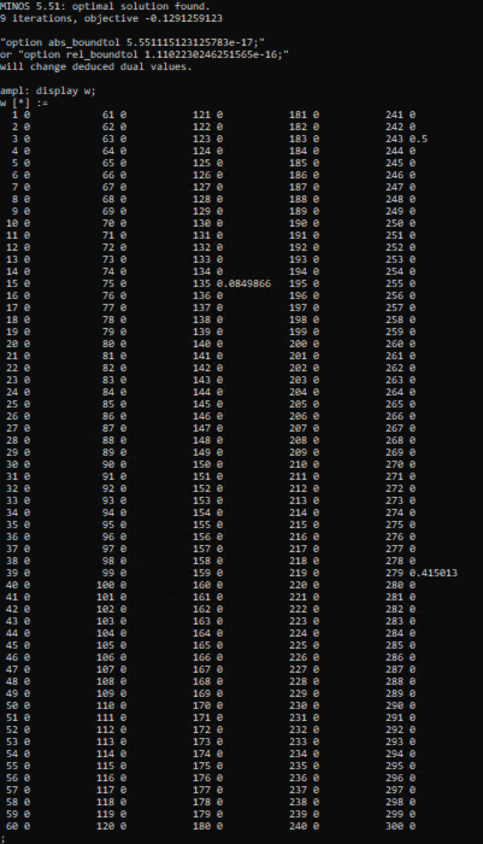

Young’s minimax model when G (target return)=0.05

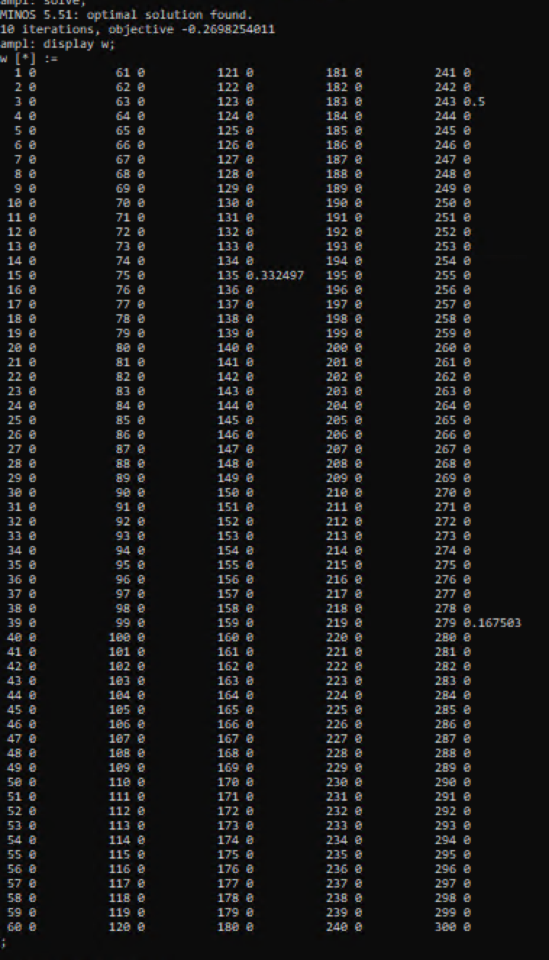

Covariance Model run for alpha = 0.03

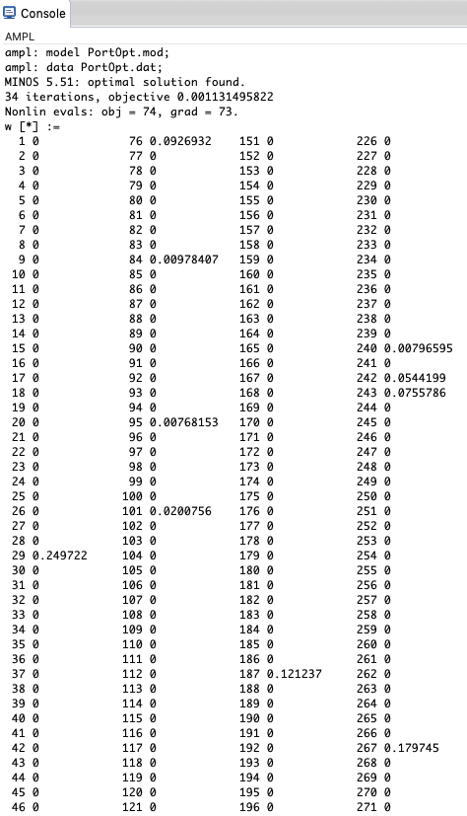

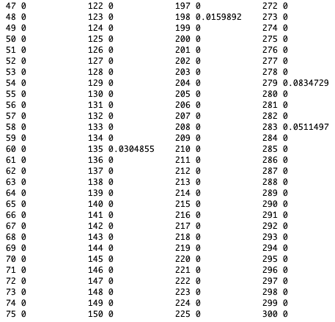

Covariance Model run for alpha = 0.04

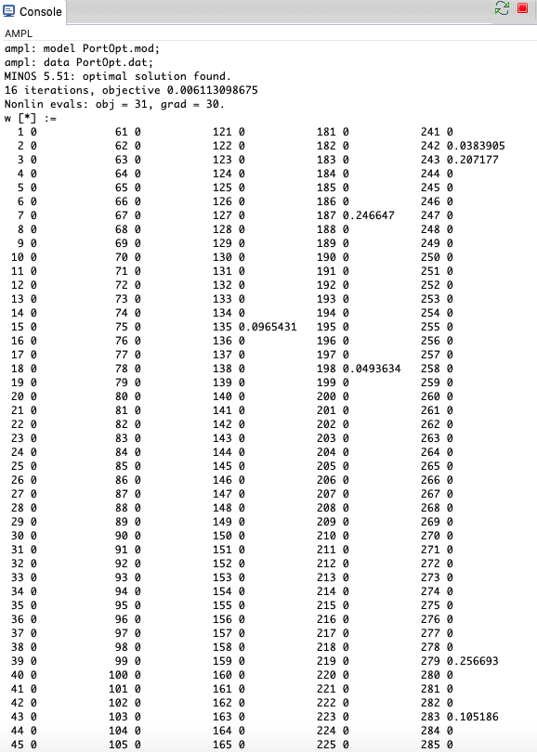

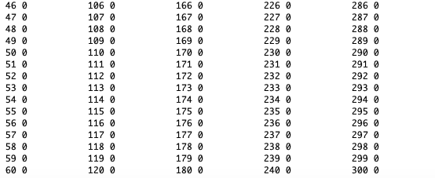

Covariance Model run for alpha = 0.05

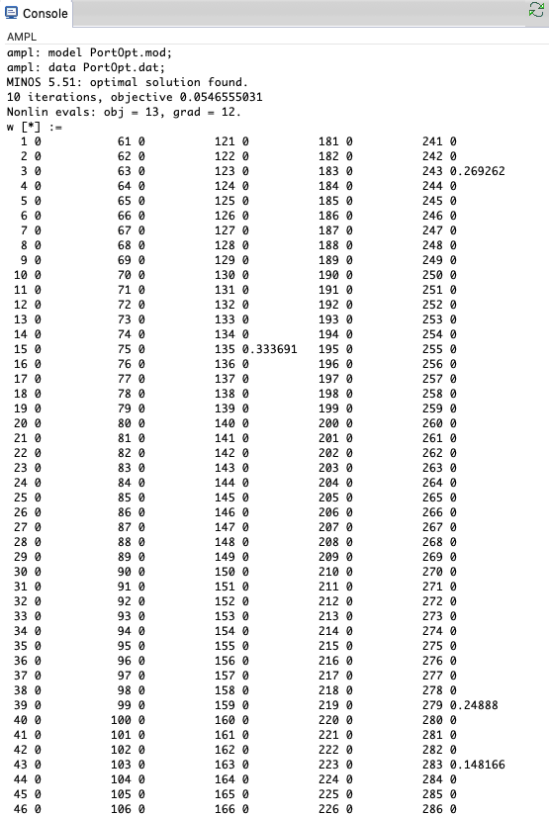

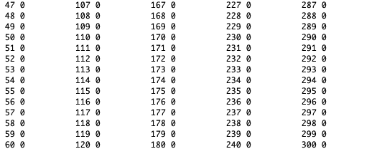

**Index and Symbol Table**

|  |  |
| --- | --- |
| Index | Symbol |
| 1 | EWL |
| 2 | SKF |
| 3 | HMY |
| 4 | TOK |
| 5 | VECO |
| 6 | ALLY.A |
| 7 | KBWB |
| 8 | TOT |
| 9 | LEE |
| 10 | IIF |
| 11 | VGM |
| 12 | IGHG |
| 13 | PAA |
| 14 | MBG |
| 15 | BGT |
| 16 | TLK |
| 17 | DZZ |
| 18 | ALL.D |
| 19 | FNK |
| 20 | UTL |
| 21 | SYNL |
| 22 | PAGP |
| 23 | NCI |
| 24 | VOYA |
| 25 | NS |
| 26 | PFLT |
| 27 | JQC |
| 28 | MCY |
| 29 | ERIE |
| 30 | BYD |
| 31 | UCFC |
| 32 | SUNW |
| 33 | ONCY |
| 34 | RJI |
| 35 | AFT |
| 36 | IGI |
| 37 | PSA.W |
| 38 | CPL |
| 39 | EXG |
| 40 | CXO |
| 41 | BVN |
| 42 | HAO |
| 43 | GXC |
| 44 | FXN |
| 45 | VKI |
| 46 | BSJJ |
| 47 | CVS |
| 48 | HST |
| 49 | E |
| 50 | SBAC |
| 51 | WAFD |
| 52 | HI |
| 53 | PXMV |
| 54 | BID |
| 55 | JAZZ |
| 56 | CMG |
| 57 | BLRX |
| 58 | PDM |
| 59 | SLAB |
| 60 | FTR |
| 61 | MLPX |
| 62 | AUY |
| 63 | USA |
| 64 | WBC |
| 65 | PTY |
| 66 | HEP |
| 67 | VCSH |
| 68 | TGB |
| 69 | PM |
| 70 | USAC |
| 71 | ORCL |
| 72 | LAND |
| 73 | MUS |
| 74 | ABB |
| 75 | HMSY |
| 76 | CNC |
| 77 | FRAN |
| 78 | JXI |
| 79 | FANH |
| 80 | BAS |
| 81 | CPTA |
| 82 | MCA |
| 83 | GFF |
| 84 | OSPN |
| 85 | AWSM |
| 86 | GPOR |
| 87 | SPDW |
| 88 | RGT |
| 89 | QRTEA |
| 90 | CATY |
| 91 | BIB |
| 92 | KYN |
| 93 | ETR |
| 94 | SPHB |
| 95 | ELMD |
| 96 | CECO |
| 97 | NTRS |
| 98 | ASYS |
| 99 | GTXI |
| 100 | HON |
| 101 | ISRG |
| 102 | ENT |
| 103 | HELE |
| 104 | RST |
| 105 | HCCI |
| 106 | TEUM |
| 107 | PZD |
| 108 | SMSI |
| 109 | FPA |
| 110 | BNDX |
| 111 | QDF |
| 112 | DVN |
| 113 | ALSK |
| 114 | REM |
| 115 | WFC.R |
| 116 | TTGT |
| 117 | HSON |
| 118 | SPTS |
| 119 | IGN |
| 120 | FLNT |
| 121 | IWX |
| 122 | ECH |
| 123 | DVAX |
| 124 | CHFS |
| 125 | ESI |
| 126 | RING |
| 127 | SCOR |
| 128 | ARR.B |
| 129 | BHR |
| 130 | JPI |
| 131 | INWK |
| 132 | STAA |
| 133 | IXP |
| 134 | LB |
| 135 | USLV |
| 136 | IUSV |
| 137 | MRVL |
| 138 | MFA |
| 139 | PSR |
| 140 | VVUS |
| 141 | DKL |
| 142 | F |
| 143 | ABUS |
| 144 | VVR |
| 145 | MSA |
| 146 | RPT |
| 147 | CHK.D |
| 148 | AOA |
| 149 | CHN |
| 150 | JPXN |
| 151 | MRC |
| 152 | GEO |
| 153 | EOD |
| 154 | CHKR |
| 155 | ATI |
| 156 | POOL |
| 157 | HFWA |
| 158 | CDMO |
| 159 | FGM |
| 160 | PLW |
| 161 | GAL |
| 162 | WCC |
| 163 | IFN |
| 164 | EGPT |
| 165 | PHK |
| 166 | GLV |
| 167 | RF.A |
| 168 | CCIH |
| 169 | ERX |
| 170 | CHT |
| 171 | HRL |
| 172 | BR |
| 173 | MEOH |
| 174 | IWP |
| 175 | IDE |
| 176 | HIX |
| 177 | TWO |
| 178 | GALT |
| 179 | VNQ |
| 180 | GTIM |
| 181 | LAD |
| 182 | CPK |
| 183 | IJS |
| 184 | PSK |
| 185 | SNPS |
| 186 | FFIN |
| 187 | CHGG |
| 188 | GHM |
| 189 | MET |
| 190 | MCF |
| 191 | SOHO |
| 192 | NVG |
| 193 | TAO |
| 194 | RVT |
| 195 | MIDD |
| 196 | EWC |
| 197 | EFG |
| 198 | HIIQ |
| 199 | STML |
| 200 | GCC |
| 201 | SPTL |
| 202 | MIDZ |
| 203 | GM |
| 204 | PLD |
| 205 | PEJ |
| 206 | SUNS |
| 207 | CYRN |
| 208 | NHC |
| 209 | BECN |
| 210 | WEC |
| 211 | ETJ |
| 212 | PCEF |
| 213 | BSCK |
| 214 | HCI |
| 215 | AGYS |
| 216 | MUC |
| 217 | NGS |
| 218 | DUC |
| 219 | IOVA |
| 220 | JWN |
| 221 | CEV |
| 222 | ODP |
| 223 | SYMC |
| 224 | VSEC |
| 225 | AHT.D |
| 226 | CZNC |
| 227 | SOXS |
| 228 | PRGX |
| 229 | TDS |
| 230 | IYW |
| 231 | FUND |
| 232 | MDSO |
| 233 | EWO |
| 234 | AIV |
| 235 | UPW |
| 236 | UIHC |
| 237 | XONE |
| 238 | IDLV |
| 239 | ATRI |
| 240 | HSII |
| 241 | NAN |
| 242 | OLED |
| 243 | AXGN |
| 244 | FRBK |
| 245 | STFC |
| 246 | GSBC |
| 247 | CPSI |
| 248 | IWR |
| 249 | IWN |
| 250 | GPX |
| 251 | BTA |
| 252 | BKN |
| 253 | PYN |
| 254 | BVSN |
| 255 | LKFN |
| 256 | HCFT |
| 257 | XOP |
| 258 | CORP |
| 259 | DPZ |
| 260 | WTR |
| 261 | VCV |
| 262 | RY |
| 263 | SHYD |
| 264 | NUV |
| 265 | SLY |
| 266 | EPAY |
| 267 | CENT |
| 268 | CGA |
| 269 | ACAD |
| 270 | RRGB |
| 271 | TDJ |
| 272 | ABC |
| 273 | AKAM |
| 274 | SNV |
| 275 | STAG |
| 276 | TRMB |
| 277 | OSBC |
| 278 | CUK |
| 279 | INGN |
| 280 | ZROZ |
| 281 | TARO |
| 282 | ARC |
| 283 | SKY |
| 284 | BBT.F |
| 285 | AGIO |
| 286 | PNR |
| 287 | QADA |
| 288 | ICLN |
| 289 | VEA |
| 290 | EVM |
| 291 | MRO |
| 292 | ALL |
| 293 | LUB |
| 294 | TSCO |
| 295 | FLXN |
| 296 | FVE |
| 297 | ROL |
| 298 | HRTX |
| 299 | TVC |
| 300 | IRM |